BUCKLEY GOLF CLUB INC
PROGRAMME 2024

JANUARY 2024
Sunday 7th. Opening Day Salver
1st Round Summer Cup. Stb
Start of Ringer's and 2's
Saturday 13th. Pedersen Cup @ Foxton. Stb
2nd Round Summer Cup
Sunday 14th. No Haggle
Sunday 21st. 3rd Round Summer Cup. Stb
Sunday 28th. Friendship Shield @ Buckley. Stb
4th Round Summer Cup

FEBRUARY 2024
Sunday 4TH. Stern Cup 1st Round Stb
Kohika Cup (Waitangi)
Sunday 11th. Presidents 1st Round TBA
Club Day Par
Sunday 18th. 'B' Pennants @ Buckley v Fielding
Club Day. Stb
Sunday 25th. Presidents 2nd Round TBA
Club Day Stb
MARCH 2024
Suday 3rd. Picard Cup 1st Round. Nett
Saturday 9th. 'B' Pennants @ Rangitikei
Sunday 10th. Van Nistleroy Cup 1st Round Stb
Sunday 17th. Presidents 3rd Round TBA
Club Day. Stb
Saturday 23rd. 'B' Pennants @ Manawatu
Sunday 24th. Stern Cup 2nd Round Stb
Sunday 31st. Picard Cup 2nd Round Nett

APRIL 2024
Sunday 7th. Presidents 4th Round TBA
Club Day Stb
Sunday 14th. 'B' Pennants Bye
Van Nistleroy 2nd Round Par
Sunday 21st. Presidents Q/F TBA
Club Day Stb
Sunday 28th. 'B' Pennants v Wanganui
@ Home
Club Day. Par
MAY 2024
Sunday 5th. Presidents S/F TBA
Van Nistleroy 3rd Round Nett
Sunday12th. Buckley Handicap 1st Round Stb
Sunday 18th. 'B' Pennants Final
Sunday 19th. Whanau Cup
Isa Robinson (mixed)
Canadian Foursomes Stb
Handicaps up
Sunday 26th. Presidents Final TBA
Buckley Handicap 2nd Round Stb

JUNE 2024
Sunday 2ND Tararua Classic
Format to be decided
Sunday 9th. Buckley Handicap 3rd Round Stb
Sunday 16th. Whanau Cup
Isa Robinson (mixed)
Canadian Foursomes Stb
Handicaps down
Sunday 23rd. Buckley Handicap 4th Round Stb
Sunday 30th. Stern Cup 3rd Round Stb
JULY 2024
Sunday 7th. Putting Cup 1st Round Par
Sunday 14th. Final's Buckley Handicap Stb
Sunday 21st. Qualifying Round Club Champs
Nett
Fourball Calcutta
Sunday 28th. Picard Cup 3rd Round Nett
Glendinning Cup at Marton

AUGUST 2024
Sunday 4th. Fourball 1st Round Stb
Sunday 11th. Club Champs 1st Round Par
Sunday 18th. Fourball 2nd Round Stb
Sunday 25th. Club Champs 2nd Round Par
Zones qualifying round

SEPTEMBER 2024
Sunday 1st. Fourball 3rd Round Stb
Sunday 8th. Club Champs 3rd Round Stb
Zones Round 1
Sunday 15th. Fourball 4th Round Stb
Sunday 22nd. Club Champs 4th Round Par
Sunday 29th. Fourball Finals Stb
Zones Round 2

OCTOBER 2024
Sunday 6th. Club Champs Final Par
Sunday 13th. Stern Cup 4th Round Stb
Zones Round 4
Sunday 20th. Picard Cup 4th Round Nett
Zones Final Round
Sunday 27th. Spare Day

NOVEMBER 2024
Sunday 3rd. Putting Cup 2nd Round Stb
Sunday 10th. Club Day Stb
Sunday 17th. Spare Day
Either Yellow Tee Challange or Ambrose
Chamberlain Shield @ Castlecliff
Sunday 24th. Club Day Stb

DECEMBER 2024
Sunday 1st. Closing Day Stb
End of Ringer's and 2's
Captain v President Day
Sunday 8th. Club Day Par
Prizegiving BBQ?
Sunday 14th Club Day Stb
Saturday 21st Xmas Cheer

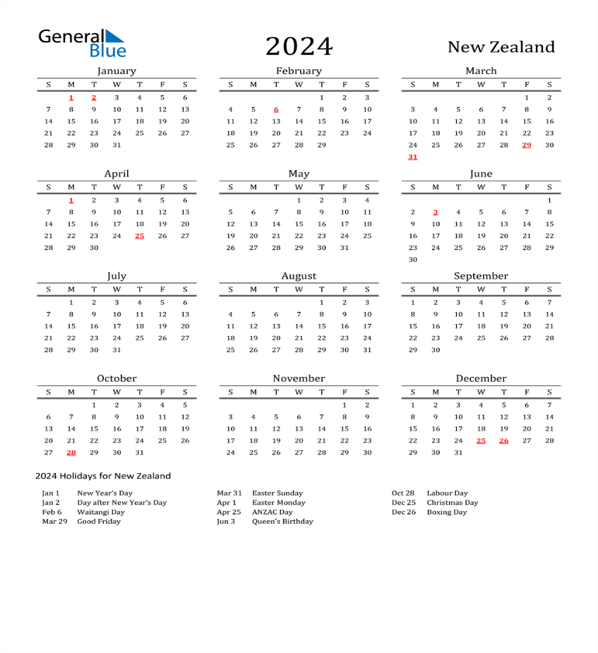
- President: Bernie Wildbore 027 4337569
- Vice President: Kerry Moore 027 4612216
- Club Captain: Scott Purcell 027 6137733
- Treasurer: Ian August 021 261 3989
- Secretary: Bridget Cameron 027 2579891

